Aim
To create and simulate a Kanban workflow using Jira or Trello by creating a board, adding tasks, and moving the tasks across To Do, In Progress, and Done columns.
Requirements
- Jira account and web browser.
- Kanban board with To Do, In Progress, and Done columns.
- Sample project tasks/cards.
Procedure
- Login to Jira/Trello using the required account.
- Create or open a new Kanban board for the project.
- Create the workflow columns: To Do, In Progress, and Done.
- Add 2 to 3 or more tasks/cards to the To Do column.
- Move selected tasks from To Do to In Progress when work starts.
- Move completed tasks from In Progress to Done.
- Observe the movement of tasks and the overall task progress on the board.
Observation
The Jira Kanban board was created successfully. The board contains three workflow stages. Initially, tasks were placed in To Do. During the simulation, tasks were moved to In Progress and then to Done after completion.
Output
Output 1 – Kanban Board with Tasks in To Do
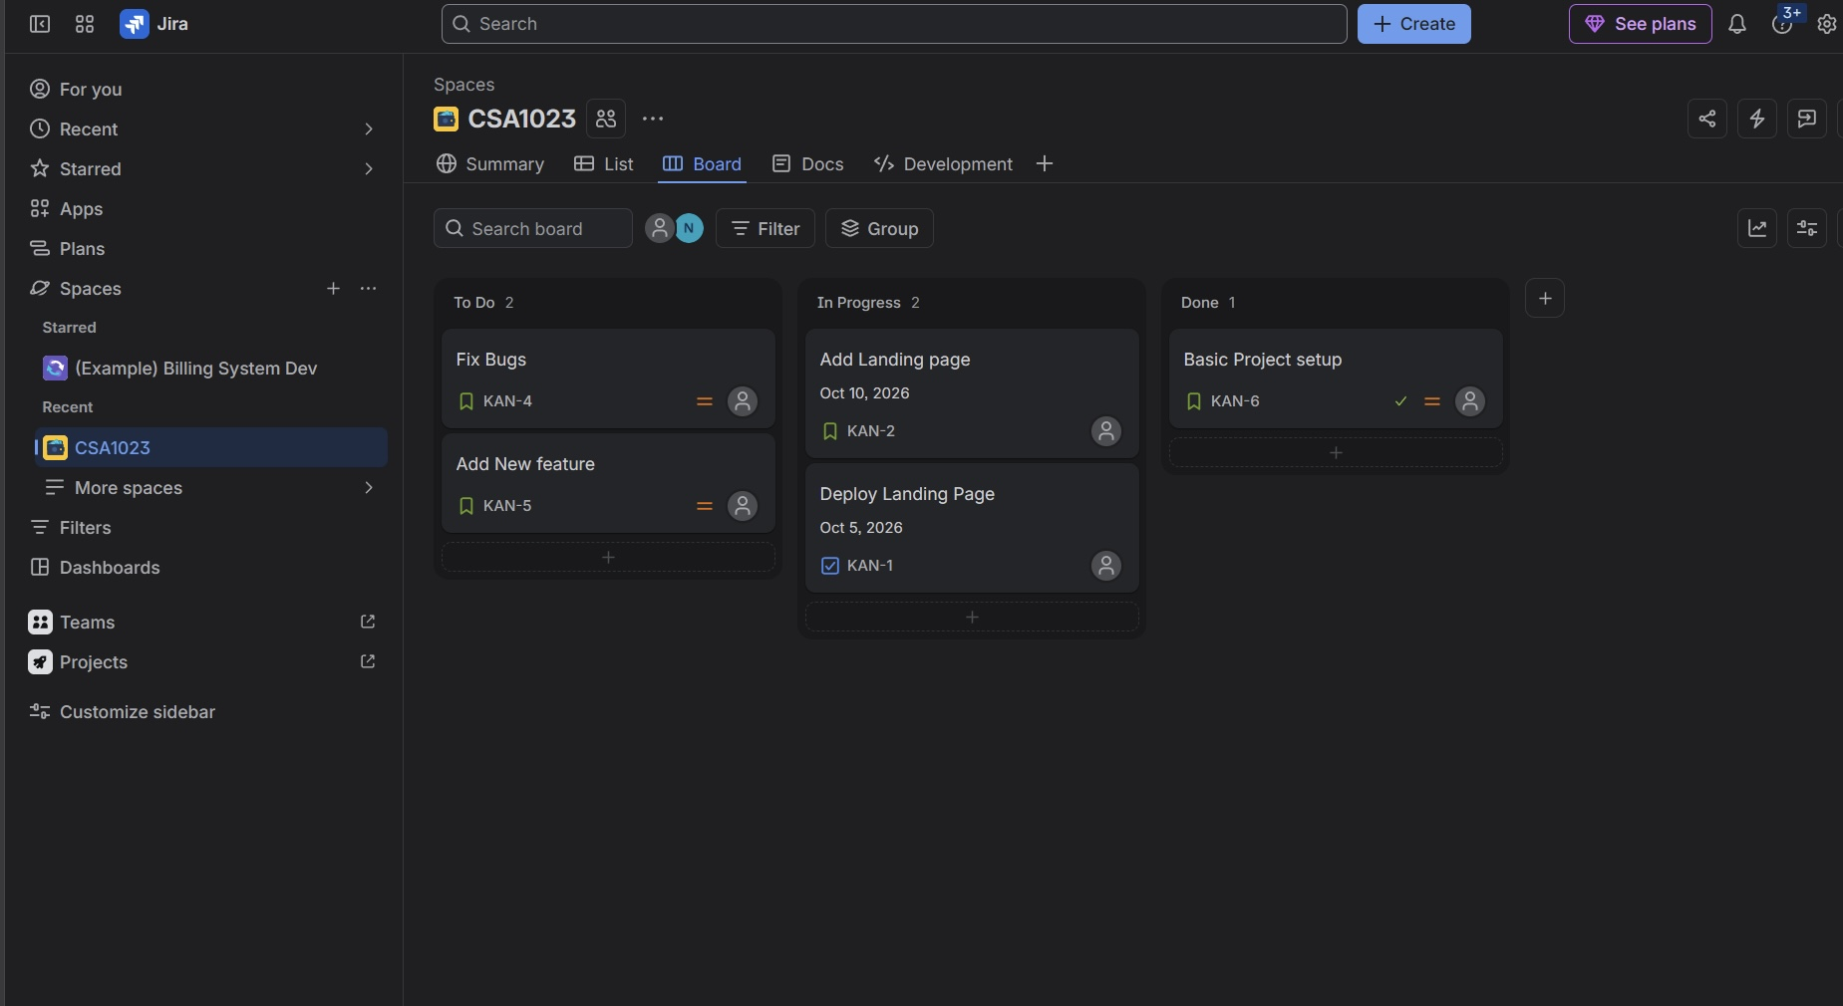
Output 2 – Tasks Moved Across the Kanban Workflow
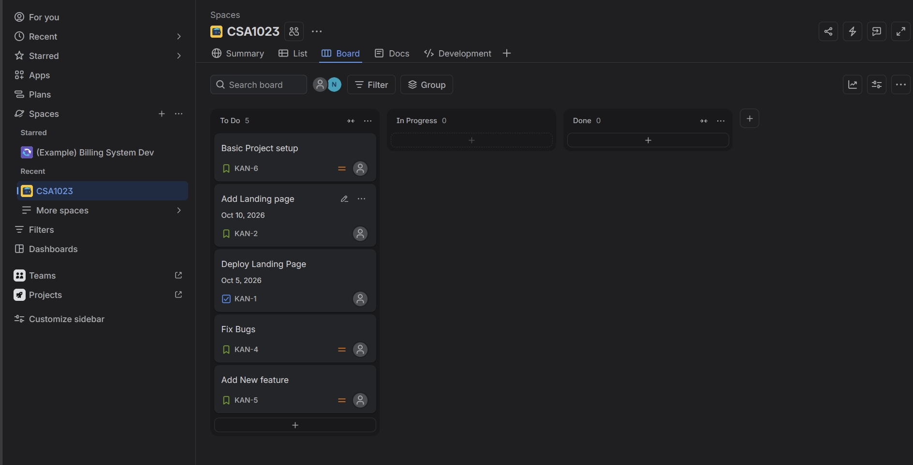
Result
Thus, a Kanban board was successfully created and simulated in Jira. The tasks were organized under To Do, In Progress, and Done columns, and the workflow was demonstrated by moving tasks between the columns. The progress of the tasks was successfully observed.

